**10. TURBULENT FLOW**

**TURBULENT FLOW:** A chaotic flow characterised by random function of velocity due to domination of inertia force over the viscous flow.

**CHARACTERISTICS OF TURBULENT FLOW:**

1. and are relatively high.
2. Velocity profile is closure to uniform velocity profile.
3. Random intermixing of fluid particles between the layers takes place.
4. Velocity of a particle randomly fluctuates w. r. t. time.
5. Extra shear stress due to momentum transfer takes place. Hence, Newton’s law of viscosity is not enough to calculate shear stress.
6. When turbulent flow meets rough surface of pipe, formation of eddies takes place.

**VELOCITY OF A PARTICLE IN TURBULENT FLOW:**

|  |  |  |  |  |  |  |  |  |  |
| --- | --- | --- | --- | --- | --- | --- | --- | --- | --- |
| |  |  | | --- | --- | |  | | | Time Avg. Velocity | Random Fluctuation Vel. |   Here,   |  |  | | --- | --- | |  |  | |  | Root mean square (RMS) of Random Fluctuating Velocity. |   Time Avg. of random fluctuating Velocity is zero. |  |
| **INTENSITY OF TURBULENCE:** It’s ratio of fluctuation per mean velocity in all 3 direction combinedly. |  |

**SHEAR STRESS IN TURBULENT FLOW:**

In turbulent flow newton’s law of viscosity is not enough to calculate shear stress. Additional turbulent, due to momentum transfer during random collisions is developed.

1. Reynolds Model for :

|  |  |  |
| --- | --- | --- |
|  |  |  |

1. Bossinesque Model for :

|  |  |  |  |
| --- | --- | --- | --- |
|  | Eddy Viscosity  is not property of fluid |  |  |

1. Prandtl’s model for :

|  |  |  |  |  |
| --- | --- | --- | --- | --- |
|  |  |  |  | Mixing Length,  Karman’s Constant |

**MIXING LENGTH:** The lateral distance travelled by a fluid particle to intermix from it’s layer to the other layer.

|  |  |
| --- | --- |
|  | Wall of pipe experience only |

**SHEAR VELOCITY OR FRICTION VELOCITY :**

An imaginary parameter which represents wall shear stress in the units of velocity.

|  |  |
| --- | --- |
|  |  |

|  |  |
| --- | --- |
| **VELOCITY PROFILE:**   1. Velocity profile is logarithmic/ Rectangular in nature. 2. & both correction Factors decreases with increase in intensity of turbulence. | **C:\Users\Shiv\AppData\Local\Microsoft\Windows\Temporary Internet Files\Content.MSO\F31ED924.tmp** |
| **SHEAR STRESS PROFILE:**   1. Laminar Sub layer region () 2. Overlap/ Buffer region 3. Outer Turbulent Region () |  |

**LAMINAR SUB LAYER REGION:**

A very thin region adjacent to the wall of a pipe where heavily dominates over .

1. The velocity profile in laminar sub layer is **almost linear**.
2. Laminar Sublayer thickness is kinematic Viscosity.
3. is important to understand the roughness characteristics of a pipe.

**ROUGHNESS IN PIPES:** Average height of irregularity at the inner wall of a pipe is called roughness in pipe ().

**HYDRODYNAMICALLY SMOOTH SURFACE:**

|  |  |
| --- | --- |
| enter image description here | enter image description here |

If the value of ‘K’ is smaller or less, then the boundary is known as Hydrodynamic Smooth. And .

For Hydrodynamic smooth pipes (),

|  |  |
| --- | --- |
|  |  |

If the value of ‘K’ is large for a boundary then the boundary is called as Hydrodynamic Rough. And .

|  |  |  |
| --- | --- | --- |
| For Hydrodynamic Rough pipes (), |  | Where, R is Radius. |

For Pipe in Transition (),

|  |
| --- |
| Hydrodynamic () means, it depends on surface, dynamic property and fluid property. |

Based on only surface roughness we can’t judge about the flow. We need both both to know about the flow.

**VELOCITY FORMULAS:**

|  |  |  |
| --- | --- | --- |
|  |  |  |

For Hydrodynamic smooth pipes,

|  |  |
| --- | --- |
|  |  |
|  |  |

For Hydrodynamic Rough pipes,

|  |  |
| --- | --- |
|  |  |
|  |  |

**COMMERCIAL PIPES:**

|  |  |
| --- | --- |
| **PRACTICAL PROBLEMS** | |
| How to measure | If is known, how to measure because it varies w.r.t.. So, finding is difficult. |

**SOLUTION:**

1. EQUIVALENT PIPE: Create other pipe with same Property such that head loss remains same. So, From the known pipe surface roughness by comparing we can obtain surface roughness of unknown pipe.
2. COLEBROOK-WHITE EQUATION:

|  |  |
| --- | --- |
|  |  |

* Graphical Representation of Colebrook-White equation is known as Moody’s chart.

1. HAALAND’S EQUATION:

|  |
| --- |
|  |

**MOODY’S CHART:**

1. For turbulent flow through Smooth pipe friction factor continuously decreases with .
2. For turbulent flow through Rough pipe friction factor initially decrease w. r. t. but after certain it remains contestant. And the critical value of is not fixed. It decreases w. r. t. .
3. For same as increases increases.
4. For laminar flow through Rough/ Smooth pipe friction factor continually decreases w. r. t. .

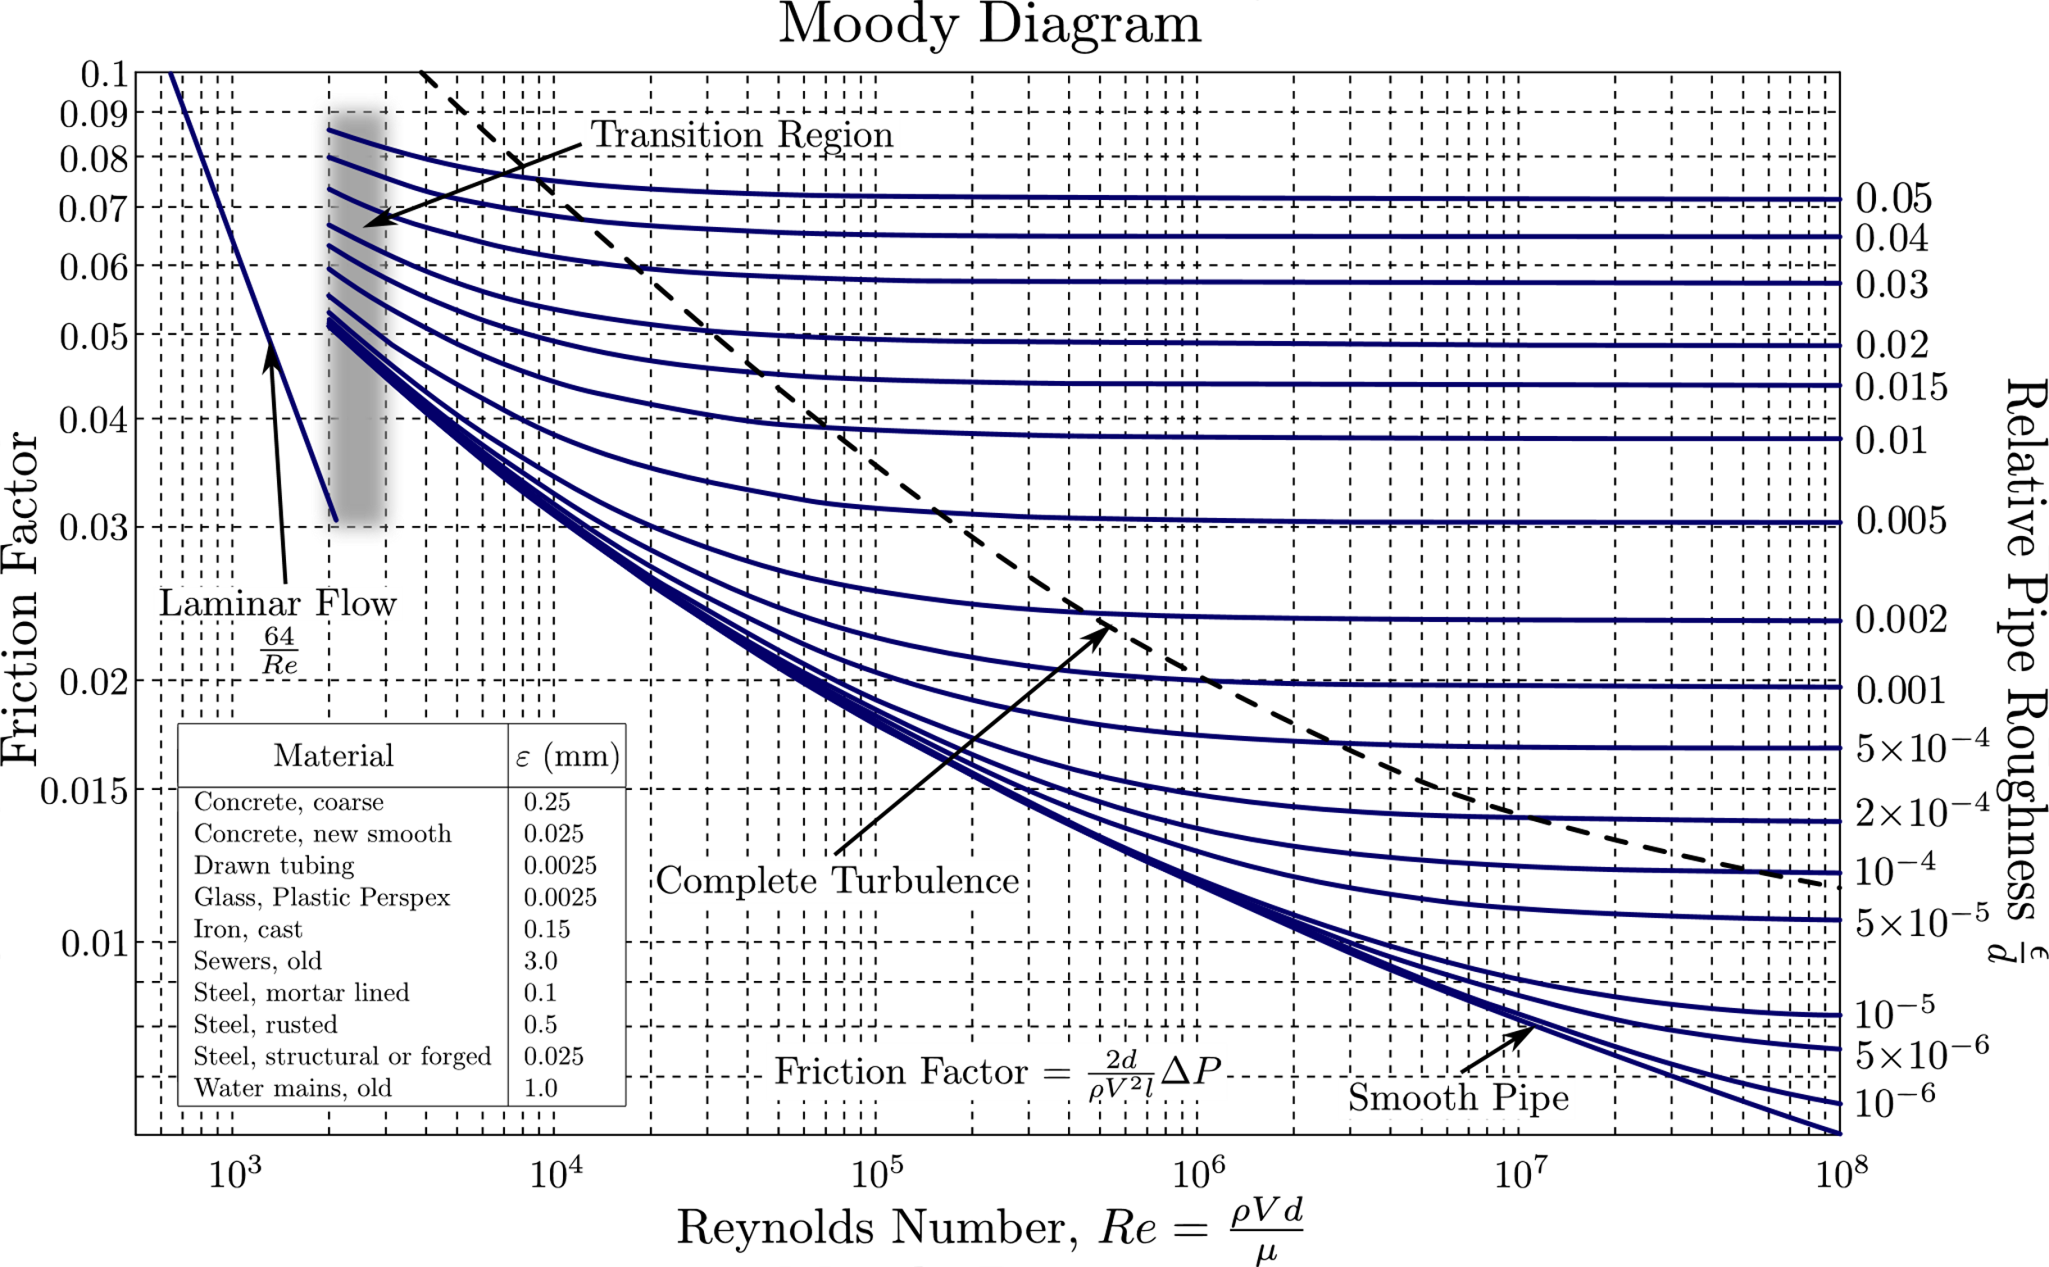

**AGEING OF PIPES:**

|  |  |
| --- | --- |
| 1. Surface roughness increases linearly w. r. t. time.   is material property and Depends surroundings. | Bottom surface roughness of a high-pressure reheater's piping as a... |  Download Scientific Diagram |